Additional question about AFG 1K

1. The range of PSK deviation is inconsistent between front panel and firmware.

In front panel, the range is 0-360 DEG.

In firmware, the range is 0-180 DEG.

Is there a bug?

1. The OUTPut[1|2]:IMPedance command is no longer documented in programmer manual. But the instrument still supports this command.

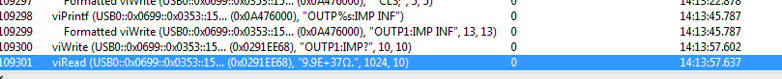

The IVI driver need the result returned by this command with model info to determine the range of amplitude and select a correct rangetable.

If this command is factory use only, could you support this command in future version firmware and document it to programmer manual like AFG3K?